9. Checks if a given number x exists in a sorted array arr using binary search. Analyze its
time complexity using Big-O notation.
Test Case:
Example X={ 3,4,6,-9,10,8,9,30} KEY=10
Output: Element 10 is found at position 5
Example X={ 3,4,6,-9,10,8,9,30} KEY=100
Output : Element 100 is not found

INPUT:
n = int(input("Enter number of elements: "))

arr = []

print("Enter the elements:")
for i in range(n):
arr.append(int(input()))

key = int(input("Enter the key: "))

arr.sort()

low = 0
high = n - 1
found = False

while low <= high:
mid = (low + high) // 2

if arr[mid] == key:
print("Element", key, "is found at position", mid + 1)
found = True
break
elif arr[mid] < key:
low = mid + 1
else:
high = mid - 1

if not found:
print("Element", key, "is not found")

Sample Output 1

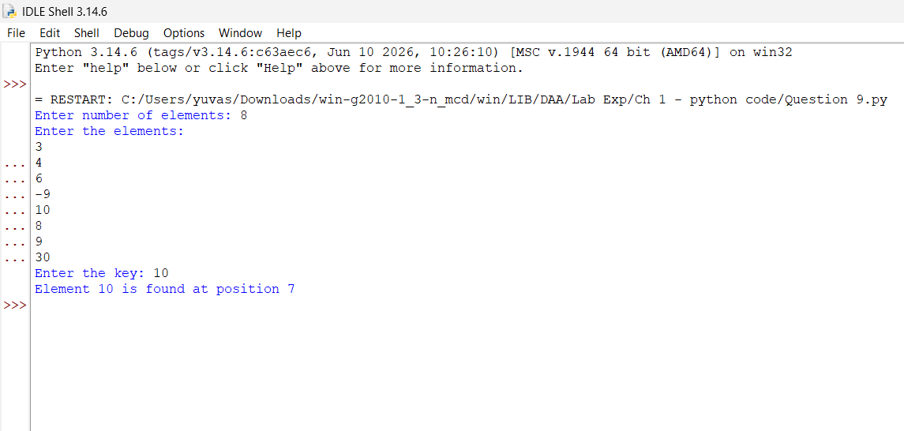

Sample Output 2
